Subtracting Decimals
How to subtract decimal number?
To subtract decimal follow the below steps:
● Write down the two decimal numbers, one number under the other number and line up the decimal points.
● Convert the given decimals to like decimals.
● Write the smaller decimal number under the larger decimal number in the column.
● Arrange the decimal numbers in the column in such a way that the digits of the same place are in the same column.
● Subtract the numbers in the column from the right.
● Remember to place the decimal point down in the answer in the same place as the numbers above it.
Eg-1) Subtract 27.59 from 31.4
Solution:
We have 27.59 from 31.4
Converting both the decimal numbers into like decimals,
31.40 - 27.59
Now arrange them in columns and subtract we get
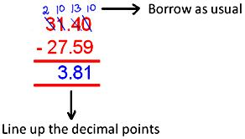

Eg-2) ) Subtract 243.86 from 402.1
Solution:
We have 243.86 from 402.1
Converting both the decimal numbers into like decimals,
402.10 - 243.86
Now arrange them in columns and subtract we get
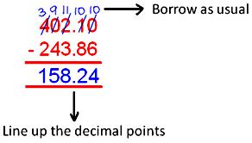
0Save
3) One number is 107.06 and the other number is 79.17. Find the difference between both the numbers.
Solution:
One number is 107.06
The other number is 79.17
Therefore, the difference between both the numbers = 107.06 - 79.17 = 27.89

